**Day 12**

// program using default constructor and Parametrized constructor

class Sample3

{

String name;

Sample3()

{

System.out.println("Default Constructor invoked");

}

Sample3(String a)

{

name=a;

}

void display()

{

System.out.println("My Name is "+name+"(by using paramtrized constructor)");

}

public static void main(String args[])

{

Sample3 obj1 = new Sample3(); // default constructor

Sample3 obj = new Sample3("Jitty"); // parametrized constructor

obj.display();

}

}

**Output**

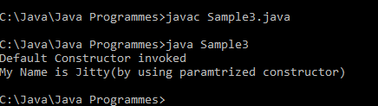

// Program using construction overloading

class Sample4

{

int num1;

float num2;

float sum;

Sample4(int a, int b)

{

num1=a;

num2=b;

sum = a+b;

}

Sample4(int a, float b)

{

num1=a;

num2=b;

sum=a+b;

}

void display()

{

System.out.println("Sum of two nos. is "+sum);

}

public static void main(String args[])

{

Sample4 obj1 = new Sample4(10,20);

Sample4 obj2 = new Sample4(20,10.5f);

obj1.display();

obj2.display();

}

}

**Output:**

